 |  | INTERNATIONAL TELECOMMUNICATION UNION  TELECOMMUNICATION  STANDARDIZATION SECTOR  STUDY PERIOD 2025-2028 |  |  | Focus Group on AI Native for Telecommunication Networks  (FG-AINN)
 |  |  |  |  | FG-AINN-215
 |  |  |  |  | Original: English
Question(s): |  |  |  | WG4 | Virtual, 10-12 February 2026
 | INPUT DOCUMENT
 | Source: |  | Sri Sivasubramaniya Nadar College of Engineering, Chennai; Free Stream Technologies; Edge Beam Wireless
 | Title: |  | AI-Driven Converged 6G Network for Scalable UAV swarm Coordination for Smart Cities
 | Contact: |  | Charan Velavan  Sri Sivasubramaniya Nadar College  of Engineering, Chennai  India |  |  |  | Mobile: +91 9884114700  E-mail: charan2520089@ssn.edu.in
 | Contact: |  | Yogender Raju  Sri Sivasubramaniya Nadar College  of Engineering, Chennai  India |  |  |  | Mobile: +91 7823937373  E-mail :yogender2520114@ssn.edu.in
 | Contact: |  | Kaythry P  Sri Sivasubramaniya Nadar College  of Engineering, Chennai  India |  |  | Mobile: +91 9840142955  E-mail :kaythryp@ssn.edu.in
 | Contact: |  | Preksha Shah  Free Stream Technologies |  |  | E-mail : preksha@freestream.ai
 | Contact: |  | Rashmi Kamran  Free Stream Technologies |  |  | E-mail : rashmi@freestream.ai
 | Contact: |  | Joe Fabiano  Edge Beam Wireless |  |  | E-mail : jfabiano@edgebeamwireless.com

Keywords: | AI-Native Networks, 6G Communication, UAV Swarm Coordination, Smart Cities, ATSC 3.0 Broadcast, Multicast Mission Delivery, Edge AI, Network Convergence, Low-Latency Control, Scalable UAV Management
Abstract: | The increasing deployment of swarms of UAVs within smart city environments for applications like surveillance, disaster response, traffic monitoring, and infrastructure inspection poses significant scalability challenges in terms of communication, coordination, and control. Traditional unicast-dominated cellular networks are inadequate to efficiently distribute shared mission information to large UAV populations while maintaining low-latency bidirectional communication crucial for control and telemetry. This PoC introduces an AI-driven, converged 6G and ATSC 3.0 broadcast network architecture poised to enable scalable UAV swarm coordination. In the proposed framework, an edge-deployed AI mission coordination server dynamically analyzes UAV telemetry and environmental context to generate mission instructions, geofencing updates, and software payloads. Shared mission data are efficiently distributed using ATSC 3.0 multicast broadcast, while latency-critical control and feedback are handled over QoS-guaranteed 6G unicast links. The PoC demonstrates spectrum efficiency improvements, reduction of backhaul load, and low-latency mission adaptation to prove the suitability of converged broadcast-cellular architectures for large-scale UAV operations in smart cities and emergency scenarios.

- Introduction

UAV and drone swarms are increasingly being deployed in smart city environments to support applications such as public safety monitoring, disaster assessment, traffic surveillance, and infrastructure inspection. As swarm sizes scale from tens to hundreds of UAVs, real-time coordination becomes a critical networking challenge. Each UAV requires continuous low-latency control and telemetry exchange while simultaneously receiving shared mission information such as geofencing boundaries, task assignments, and route updates.
Existing cellular-centric approaches rely primarily on point-to-point unicast communication, which results in excessive backhaul utilization, increased latency, and limited scalability when applied to large UAV swarms. Broadcast technologies such as ATSC 3.0 provide efficient one-to-many delivery but lack native support for bidirectional control and differentiated latency handling.
This PoC proposes an AI-native converged 6G–ATSC 3.0 architecture in which delivery decisions are made dynamically at the network edge. An AI mission coordination platform classifies mission traffic based on urgency, swarm density, congestion conditions, and system health, and automatically selects unicast, multicast, or broadcast transmission modes. This intelligent separation of shared mission dissemination from latency-critical control traffic enables scalable, efficient, and adaptive UAV swarm coordination aligned with FG-AINN objectives.

- Proof of Concept Summary
Submission Id | FG-AINN-PoC-215
Title | AI-Driven Converged 6G Network for Scalable UAV swarm Coordination for Smart Cities
Created by | Team: NVK  Team Members: Charan Velavan, Yogender Raju,  Internal Guide: P. Kaythry
Creation date | 8th January 2026
Category | AI-Native Distributed Decision Making
PoC Objective | - Demonstrate converged 6G–ATSC 3.0 communication for scalable UAV swarm coordination by combining broadcast multicast delivery with low-latency unicast control.  - Validate AI-driven mission coordination at the network edge, including dynamic geofencing, flight path updates, and delivery mode selection (broadcast vs. unicast).  - Evaluate scalability and bandwidth efficiency by multicasting shared mission data to many UAVs  - Verify low-latency and reliability of mission-critical updates and real-time telemetry exchange under dense UAV deployment scenarios.  - Assess system performance and feasibility in a dense urban environment with high-rise buildings, variable interference, and dynamic obstacles, conventional UAV operations over unicast-only cellular networks, where each UAV receives mission data individually and mission planning is static are evaluated. Metrics include latency, reliability, spectrum efficiency, and mission accuracy. Results show that the integration of AI with broadcast and unicast significantly improves scalability, ensures low-latency mission updates, dynamically adapts to environmental changes, and outperforms traditional unicast-only as well as non-AI multicast approaches in complex smart city UAV operations.
Description | The PoC implements a UAV swarm simulation integrated with an edge AI inference server and a real-time mission control dashboard. A Python-based UAV simulator models 150–300 UAVs with realistic geo-coordinates, kinematic motion, battery dynamics, spatial clustering, conflict generation, and congestion evolution.  An edge-deployed AI server executes a trained machine learning model that consumes telemetry-derived features including swarm size, data payload size, priority, spatial density, congestion level, latency requirements, packet loss estimates, and predicted congestion trends. Based on model confidence and adaptive thresholds, the AI selects the optimal delivery mode (unicast, multicast, or broadcast). A rule-based fallback mechanism ensures safe operation under low-confidence or resource-constrained conditions.  Mission decisions, latency metrics, bandwidth savings, and system health indicators are visualized in real time through a Streamlit-based mission control dashboard, enabling scenario injection, manual testing, and performance analysis.
POCs Test Setup | - Real UAV Platform – Physical UAV with onboard compute module acting as UE, executing mission commands and sending telemetry.  - UAV Communication Interfaces – ATSC 3.0 (emulated receiver) for multicast mission data; cellular) unicast for telemetry, control, and acknowledgements.  - Broadcast Edge Node (AI Server) – Edge-deployed AI engine for mission coordination, dynamic geofencing, conflict prediction, and delivery mode selection.  - ATSC 3.0 Broadcast Core (Emulated) – Packages mission data using ROUTE/MMTP and manages service signalling (SLT/ESG) for multicast delivery.  - Cellular Core (Emulated / Commercial) – Provides low-latency unicast connectivity with QoS support for UAV control and feedback.
Data Sets | - UAV Telemetry Data  - Contents: GPS position, altitude, velocity, heading, and link status.  - This Data will be collected manually and synthesized.  - UAV Mission Data  - Contents: Waypoints, geofencing coordinates, and task assignments.  - Documentation on Onboard Logs: https://docs.px4.io/main/en/log/flight_log_analysis  - Sample Intended Mission data:  https://www.globhe.com/sample-drone-data  - Environmental Data  - Contents: No-fly zones and obstacles in the smart city simulation.  - Use: Context for UAV navigation and geofencing logic in the simulation.  - Sources from Google Earth/ https://catalog.data.gov/dataset/no-fly-zones (US), https://digitalsky.dgca.gov.in/airspace-map/#/app (India).  - Github Repository  - https://github.com/ryr007/Buildathon2.0
Demo and Evaluation | The demo follows the bidirectional operational model illustrated in Figure 1, where shared mission data is delivered through broadcast channels while real-time telemetry and control feedback are maintained over unicast links. The demo illustrates real-time UAV telemetry collection, AI-based mission analysis, dynamic geofencing, and intelligent delivery mode selection between ATSC 3.0 multicast and 6G unicast communication. Shared mission data is broadcast to UAVs, while real-time control and feedback are handled via unicast links.  Performance is evaluated using metrics such as  - End-to-end latency,  - cellular backhaul load reduction,  - Scalability (# of UAVs supported)  - Reliability (packet success rate).  The AI-assisted converged approach is compared against a unicast-only cellular baseline to demonstrate improvements in scalability, bandwidth efficiency, and mission coordination reliability.
PoC Observation and discussions | The Proof of Concept demonstrates that an AI-driven converged 6G–ATSC 3.0 architecture can significantly enhance the scalability and efficiency of UAV swarm coordination in smart city environments. Simulation results with 150–300 UAVs show that distributing shared mission data via multicast and broadcast substantially reduces redundant transmissions and cellular backhaul load when compared to unicast-only communication.  The edge-deployed AI Mission Coordination Platform effectively analysed UAV telemetry, spatial density, and congestion trends to dynamically select the optimal delivery mode. Latency-critical control and telemetry traffic were consistently preserved over unicast links, while non-time-critical mission updates were offloaded to multicast or broadcast channels. This intelligent traffic separation-maintained quality of service for real-time UAV control even under dense and congested operating conditions.  Although the AI-driven converged approach introduced moderate processing overhead relative to direct unicast transmission, the overall system achieved superior scalability, spectrum efficiency, and operational robustness. The results confirm that AI-native delivery mode selection combined with broadcast–cellular convergence offers a practical and resilient solution for large-scale UAV swarm operations in dynamic smart city scenarios.
Conclusion | - This PoC validates the feasibility and advantages of an AI-native converged 6G–ATSC 3.0 architecture for scalable UAV swarm coordination in smart city environments. By dynamically combining multicast/broadcast dissemination for shared mission data with low-latency unicast communication for control and telemetry, the proposed system overcomes the scalability limitations of unicast-only cellular networks.  - The integration of edge AI enables adaptive mission coordination, congestion-aware delivery decisions, and robust operation under dynamic conditions. The observed improvements in scalability, spectrum efficiency, and operational reliability demonstrate the suitability of broadcast–cellular convergence as a foundational capability for future 6G-enabled UAV systems.
Open Problems and Future Work | - Real-world integration with licensed ATSC 3.0 broadcast infrastructure.  - Secure authentication and encryption of broadcast mission data.  - Advanced AI models for predictive swarm behaviour and anomaly detection.  - Dynamic broadcast zone adaptation under high UAV mobility.  - Large-scale field trials with multiple real UAVs.
References | - ITU-T Y.2012,  - ATSC A/300 – ATSC 3.0 System Standard,  - Y.1541  - ITU-R Framework on IMT-2030 (6G Vision)

3. Implementation proposal

Phase 1: System Architecture and Environment Setup
- The proposed system is implemented as a simulation-based architecture for AI-driven UAV swarm coordination in smart city environments, as illustrated in Figure 1. The architecture consists of four logical components:
- UAV Swarm (Digital): A virtual swarm representing multiple UAVs operating in real geo-coordinates
- Edge AI Mission Coordinator: An edge-based intelligence unit responsible for decision-making
- Communication Layer: An abstracted converged communication layer supporting command dissemination and feedback
- Mission Control Dashboard: A monitoring and visualization interface for system performance
- The simulation environment is configured to support both forward communication flow (mission commands from the AI coordinator to UAVs) and feedback flow (telemetry and acknowledgements from UAVs to the AI coordinator).
Outcome:
The simulation environment is prepared with clearly defined forward and feedback communication paths for UAV swarm coordination.

Phase 2: UAV Telemetry and Feedback Simulation
- In this phase, the UAV swarm generates continuous telemetry and contextual data, including position, battery status, swarm density, and task priority. This telemetry is transmitted from the UAV swarm to the Edge AI Mission Coordinator, following the feedback path illustrated in Figure 1.
- The feedback flow enables the AI coordinator to maintain real-time awareness of the swarm state and operational conditions. Acknowledgements and status updates from UAVs are also included to ensure reliable bidirectional communication within the simulation.
Outcome:
A stable and reliable feedback mechanism is established between the UAV swarm and the Edge AI Mission Coordinator.

Phase 3: Mission Decision and Forward Communication
- Upon receiving telemetry data, the Edge AI Mission Coordinator analyzes the swarm state and predicts congestion or conflicts within the operating environment. Based on this analysis, the AI engine determines the appropriate delivery mode for mission data, selecting among unicast, multicast, or broadcast communication.
- Mission decisions and control data—such as routing instructions, geofencing updates, and task assignments—are forwarded to the Communication Layer, which delivers the commands to the UAV swarm. This process corresponds to the forward communication flow shown in the sequence diagram.
Outcome:
Mission commands are adaptively delivered to UAVs based on real-time swarm and network conditions.

Phase 4: AI-Based Mission Coordination and Execution
- The AI engine continuously coordinates swarm operations by performing dynamic mission updates, conflict detection, and task reassignment. Geofencing rules and navigation paths are adjusted as required to ensure safe and efficient swarm operation.
- Based on the received commands, simulated UAVs execute smart city missions such as surveillance, traffic monitoring, disaster response, and infrastructure inspection. UAVs send acknowledgements and execution status back to the AI coordinator through the feedback channel, enabling closed-loop control.
Outcome:
Continuous AI-driven mission coordination is achieved through integrated forward and feedback communication.

Phase 5: Simulation Execution and Performance Evaluation
- The simulation is executed across multiple mission scenarios to evaluate system performance. Telemetry feedback, command latency, packet loss indicators, and task completion reports are collected throughout the simulation.
- Performance metrics are forwarded to the Mission Control Dashboard, where real-time visualization of swarm behavior and network performance is provided. Key performance indicators such as latency, reliability, scalability, and mission accuracy are analyzed to assess system effectiveness.
Outcome:
The results demonstrate the effectiveness of AI-driven coordination and converged communication in supporting scalable and efficient UAV swarm operations.

3.a Description of the test setup
The test setup is designed to validate an AI-driven converged 6G–ATSC 3.0 communication architecture for scalable UAV swarm mission coordination in a smart city scenario. The logical interaction and message flow, as illustrated in the sequence diagram (Figure 1), highlights the step-by-step exchange of control, telemetry, and mission data among the UAV swarm, the edge AI decision engine, the 6G cellular network, and the ATSC 3.0 broadcast system.
In this setup, UAVs periodically transmit status updates and network measurements (latency, congestion, battery level, and density) to the edge AI server via the 6G unicast link. Based on these inputs, the AI engine performs real-time inference to determine the optimal delivery mode—unicast, multicast, or broadcast—for the next transmission interval. The selected communication strategy is then enforced by routing shared mission data through ATSC 3.0 multicast/broadcast channels, while latency-critical control and telemetry traffic continues over 6G unicast links.
The sequence diagram further illustrates a closed-loop feedback mechanism, where the outcome of each transmission decision is continuously monitored and fed back into the AI model. This enables adaptive decision-making in response to changing swarm density, traffic load, and radio conditions. The setup is implemented as a hardware- and software-in-the-loop validation platform, combining simulated UAV swarms with real network services and edge intelligence.
Overall, the test setup enables end-to-end evaluation of real-time control, mission dissemination, and adaptive communication switching, closely reflecting practical deployment conditions. By explicitly modeling decision inference, network selection, and feedback in the sequence diagram, the architecture demonstrates how AI-assisted convergence of 6G and ATSC 3.0 can support efficient, scalable, and resilient UAV swarm operations in smart city environments.
Test Setup Components:
• UAV Swarm – Python-based simulator modeling UAV motion, battery drain, spatial clustering, conflicts, and telemetry feedback for 150–300 UAVs using real geographic coordinates.
• Edge AI Mission Coordination Server – Raspberry Pi–hosted Flask server performing ML-based inference, adaptive confidence thresholding, and resource-aware fallback decisions.
• ATSC 3.0 Broadcast Path (Emulated) – Represents multicast dissemination of shared mission data such as geofencing updates and route plans.
• 6G Cellular Path (Emulated) – Provides low-latency unicast connectivity for telemetry, acknowledgements, and mission-critical commands.
• Mission Control Dashboard – Streamlit-based interface offering real-time visualization, scenario triggering, manual test injection, and performance analytics.

Communication Flow
The forward path distributes shared mission data via multicast/broadcast channels, while the feedback path carries telemetry and acknowledgements via unicast links. AI-driven delivery mode selection ensures that latency-sensitive traffic is isolated from bulk mission dissemination.

AI-Based Mission Coordination
The AI Mission Coordination Platform operates as an edge-native inference engine. At each decision interval, a feature vector is generated from UAV telemetry and environmental context, including:
- Number of UAVs requiring updates
- Mission data size
- Priority level
- Spatial density and region count
- Estimated and predicted congestion
- Latency requirements
- Battery state
- Packet loss estimates
A trained ML classifier outputs delivery mode probabilities, which are evaluated against an adaptive confidence threshold. When confidence is insufficient or system resources are constrained, a deterministic rule-based fallback ensures safe and predictable operation. This hybrid AI–rule framework provides robustness, explainability, and real-time responsiveness.

Simulation and Performance Evaluation
The simulation executes dynamic mission scenarios including normal operation, critical single-UAV updates, multicast cluster updates, and broadcast swarm updates. Performance metrics collected include:
• End-to-end latency (model, network, total) • Bandwidth used vs. unicast baseline • Bandwidth savings percentage • Decision distribution across delivery modes • Congestion and traffic trend evolution
Results confirm that multicast and broadcast delivery significantly reduce redundant transmissions and backhaul load as swarm size increases, while unicast remains reserved for latency-critical control traffic.
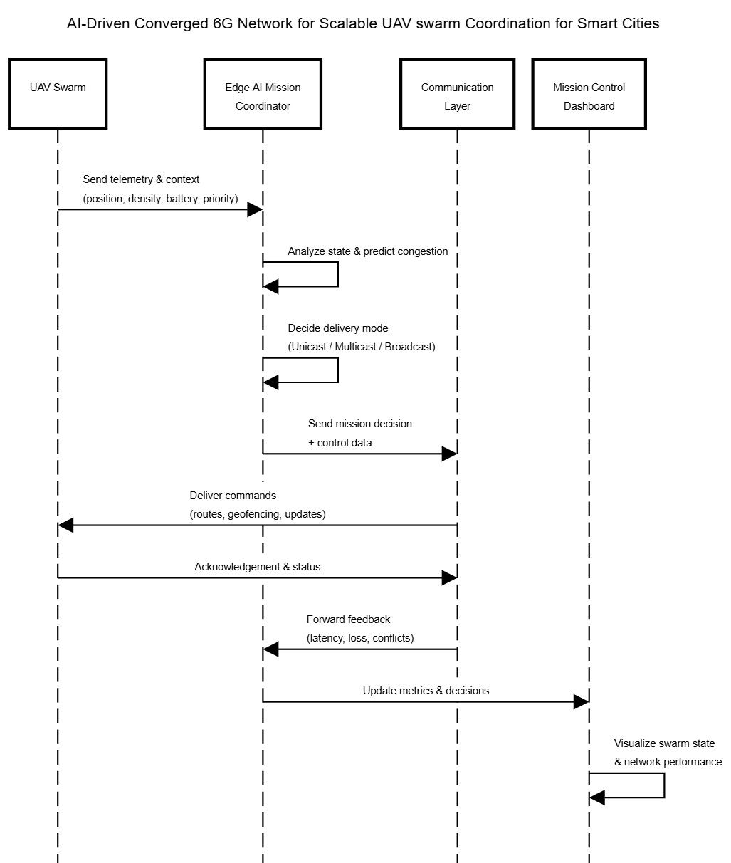
Sequence Diagram:

Figure 1: Flow Diagram of the Network
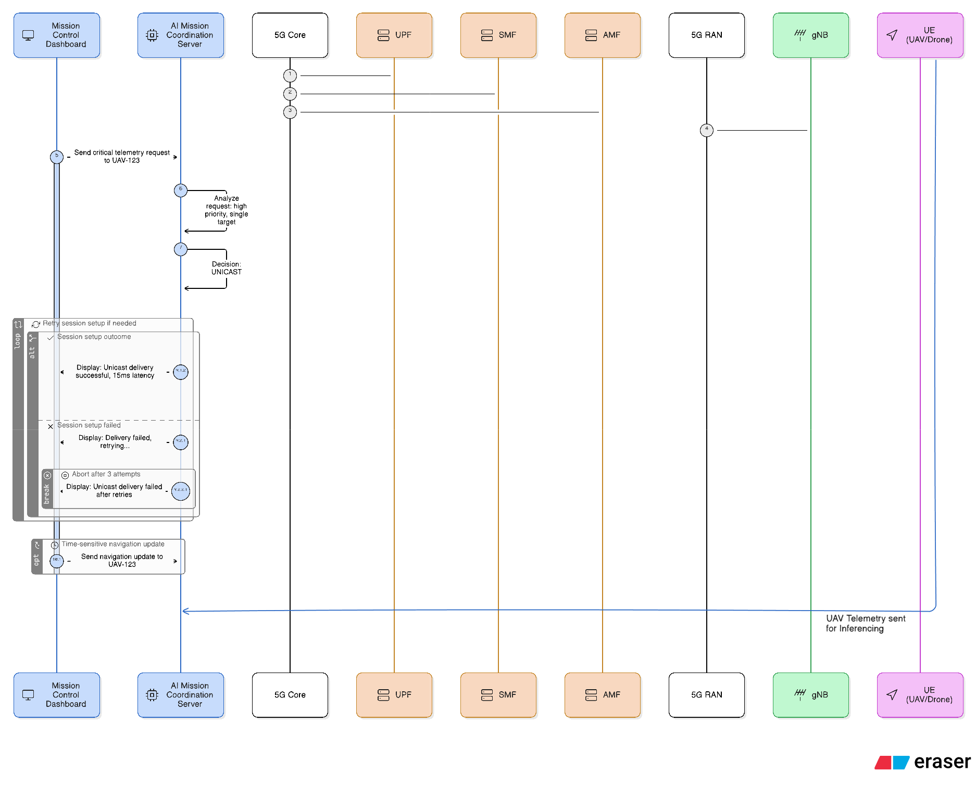
Figure 2: Sequence Diagram for Unicast

Figure 2: Unicast Communication Flow (5G/6G Network)
When Mission Control sends a critical command to a specific UAV (like an emergency stop to UAV-42), the AI Server recognizes it as a single high-priority target and selects UNICAST mode. The message flows through the 5G/6G cellular network—from the Core functions (UPF, SMF, AMF) through the RAN base station (gNB) to the individual UAV. The UAV acknowledges receipt, completing the round-trip in under 50ms. This ensures real-time, guaranteed delivery with immediate feedback for latency-critical individual commands.

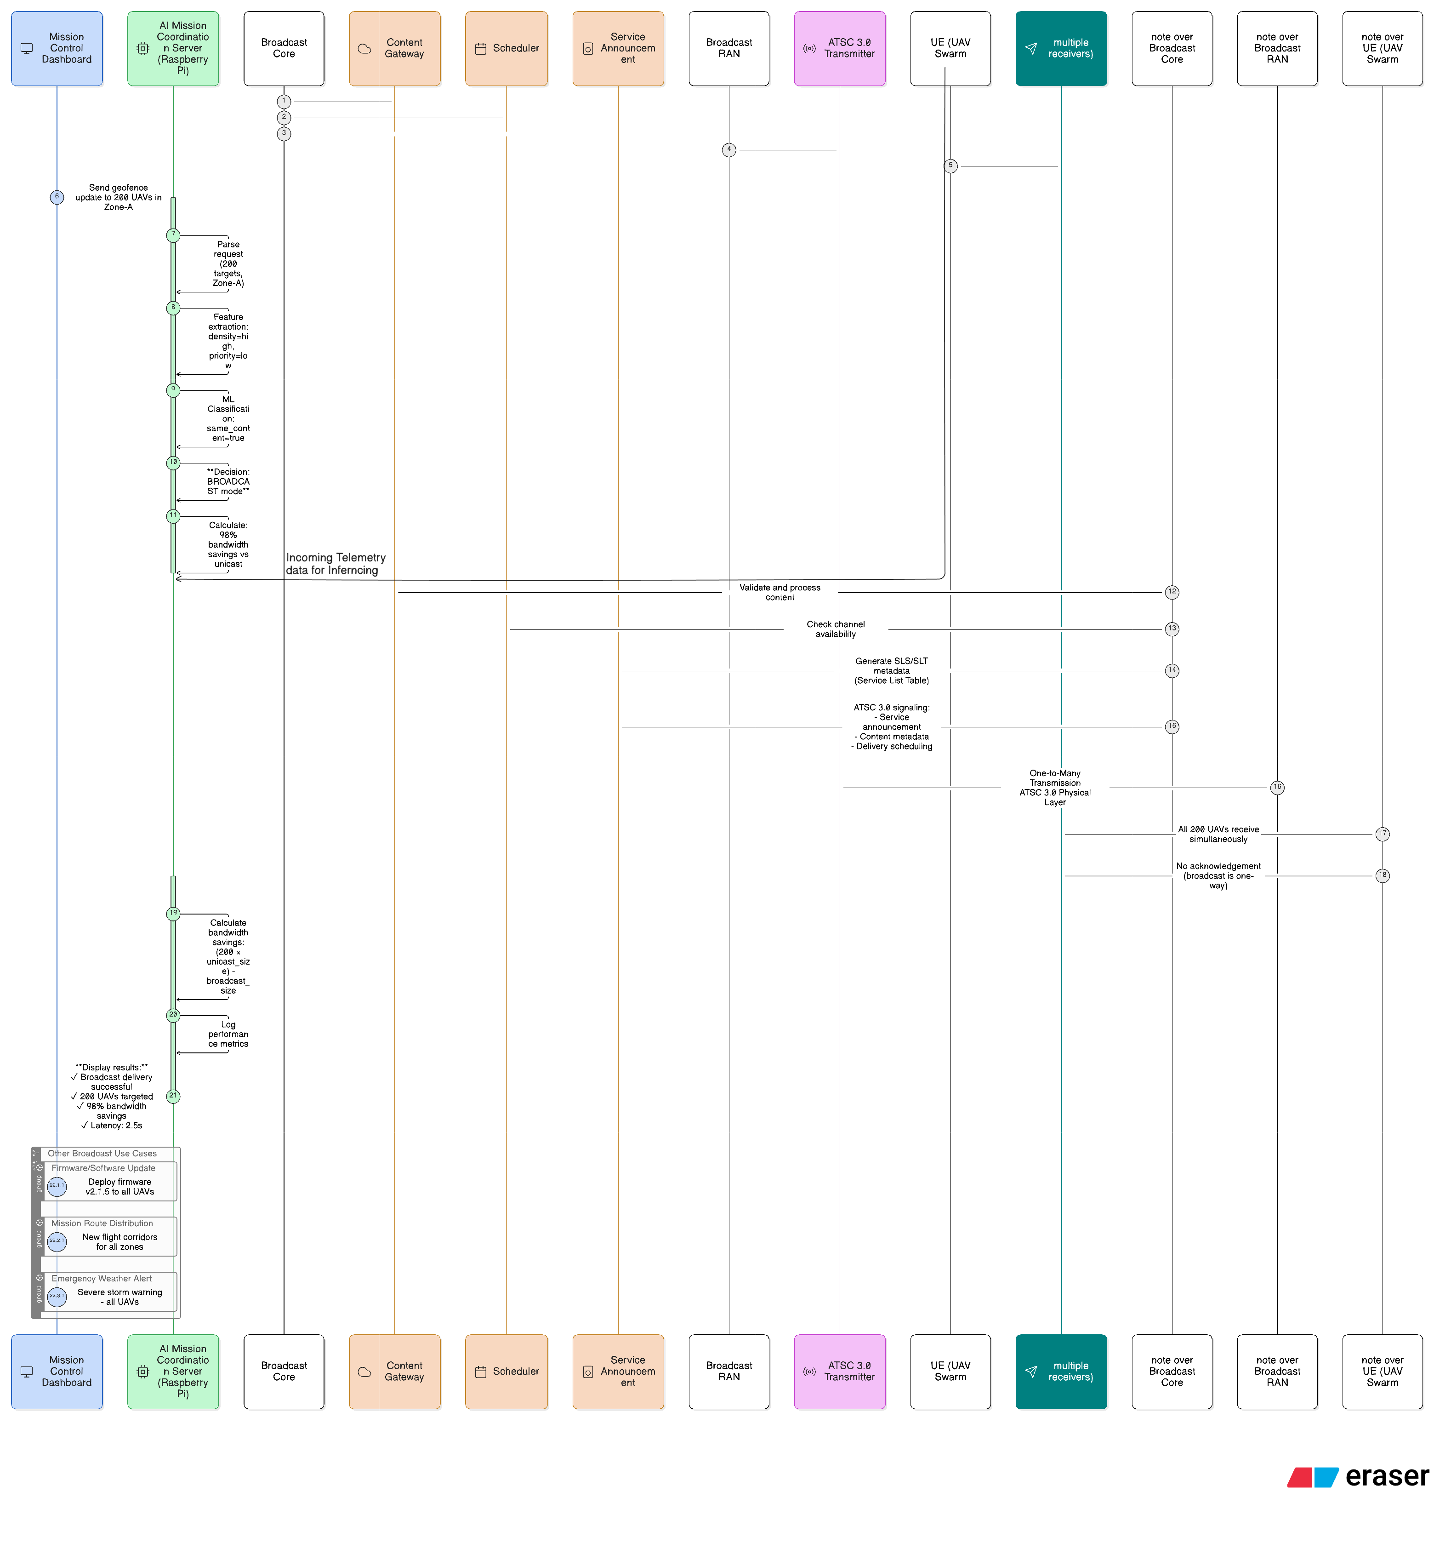
Figure 3: Sequence Diagram for Multicast/Broadcast

Figure 3: Broadcast/Multicast Communication Flow (ATSC 3.0 Network)
When Mission Control needs to update 200 UAVs with the same geofencing data, the AI Server identifies this as a broadcast scenario and calculates 98% bandwidth savings versus individual messages. The content package goes to the Broadcast Core, which schedules a transmission slot and announces the service. The ATSC 3.0 Transmitter then broadcasts once, and all 200 UAVs receive simultaneously in 2-3 seconds. This one-way transmission (no acknowledgements) maximizes efficiency for mass distribution like firmware updates or zone-wide alerts—one transmission replaces hundreds of individual messages.

3.b Demo proposal

Functional and P+erformance Requirements
Req-1: AI-Network Integration
- AI Mission Coordination Server integrated with UAV Swarm Digital simulator
- Real-time telemetry processing (position, density, battery, congestion)
- ML-based delivery mode classification: 6G unicast, 5G eMBMS multicast, ATSC 3.0 broadcast
- Adaptive confidence thresholding with rule-based fallback
Req-2: Mission Service Template Knowledge Base
- Pre-defined templates: geofencing updates, route changes, firmware updates, emergency alerts, telemetry requests
- Template metadata: priority level, target scope, latency sensitivity, data size, acknowledgement type
- Enables pattern learning and optimized delivery mode selection
Req-3: QoS Preservation
- Maintain unicast telemetry/control latency <50ms during concurrent broadcast transmissions
- Guarantee ≥99.9% delivery reliability for mission-critical unicast traffic
- Predictive congestion analysis prevents broadcast scheduling during peak unicast demand
- Real-time network health monitoring with performance tracking per communication mode
Req-4: Edge Computing Efficiency
- Raspberry Pi resource constraints: CPU ≤70%, Memory ≤2GB, Inference latency ≤100ms
- Support 150-300 concurrent UAV telemetry streams
Req-5: Bandwidth Optimization
- ≥90% savings for broadcast-suitable content vs. unicast
- ≥60% savings for multicast-suitable content vs. unicast
- Dynamic threshold adjustment based on congestion and UAV density

Req-6: Scalability
- Horizontal scaling from 150 to 300+ UAVs without performance degradation
- Real-time adaptation to swarm density and mission priority changes

Toolsets
AI / Edge Computing
- Python 3.8+
- TensorFlow Lite or PyTorch (optimized for Raspberry Pi)
- Scikit-learn for ML classification models
- Flask/FastAPI for REST API implementation
- NumPy, Pandas for telemetry data processing
ATSC 3.0 Broadcast Emulation
- libatsc3 (open source) for ROUTE/MMTP datacasting protocols
- Custom Python wrappers for broadcast gateway and scheduler simulation
- ATSC 3.0 service announcement generation tools
Cellular Network (5G/6G)
- NS-3 network simulator for 5G Core (AMF, SMF, UPF) and RAN emulation
- 5G eMBMS/multicast module for group communication
- Custom 6G unicast channel models with ultra-low latency profiles
- MATLAB (optional) for advanced radio propagation modeling
UAV Swarm
- Python simulation framework with GeoPandas for real geo-coordinates
- Mobility models (random waypoint, cluster-based movement)
- Battery drain and conflict detection algorithms
- Spatial clustering (DBSCAN/K-means) for density estimation
Mission Control Dashboard
- Dash/Plotly or Streamlit for web-based visualization
- Real-time map rendering (Folium, Mapbox, or Leaflet.js)
- 3D UAV visualization (Three.js or Plotly 3D)
- Chart libraries for latency/bandwidth/congestion analytics
Edge Hardware
- Raspberry Pi 4 (4GB/8GB RAM) for AI Mission Coordination Server
- Linux-based UAV onboard compute (simulated or Jetson Nano for real deployment)
Containerization & Orchestration (Optional)
- Docker for component isolation (AI Server, Simulator, Dashboard)
- Docker Compose for multi-container deployment
- Kubernetes (lightweight K3s) for edge orchestration
Development & Testing
- Git/GitHub for version control
- Pytest for unit and integration testing
- Locust or Apache JMeter for load testing (scalability validation)
- Prometheus + Grafana for resource monitoring

Test Cases Corresponding to Requirements
TST-1: AI-Driven Dynamic Communication Mode Selection
The AI Mission Coordination Server is triggered by introducing test scenarios in the UAV Swarm Digital simulator:
- Scenario A: Geofencing boundary change affecting 200+ UAVs in Zone-A
- Scenario B: Critical navigation command to single UAV-42
- Scenario C: Route update for 25 UAVs in high-density cluster
Expected Result:
- AI correctly classifies delivery mode (broadcast for Scenario A, unicast for Scenario B, multicast for Scenario C) with ≥85% confidence
- Broadcast/multicast messages successfully delivered via ATSC 3.0/5G eMBMS
- Critical unicast commands delivered via 6G with <50ms latency
- Dashboard displays decision rationale, confidence scores, and bandwidth savings metrics
- Rule-based fallback activates when ML confidence <threshold

TST-2: Mission Service Template Knowledge Base Impact Analysis
The system performance is measured and compared across two configurations:
- Config A: AI server without Mission Service Template KB (baseline)
- Config B: AI server with KB enabled (pre-trained templates for geofencing, routes, firmware updates)
Test Procedure:
- Execute 100 mixed mission requests (30% geofencing, 40% route updates, 20% telemetry, 10% firmware)
- Measure: delivery mode accuracy, inference latency, bandwidth usage, delivery completion time
Expected Result:
- Improved accuracy: ≥20% increase in optimal delivery mode selection with KB
- Reduced bandwidth: ≥30% reduction in total network bandwidth consumption
- Faster inference: ≥15% reduction in AI decision latency
- Better mission reuse: Faster template matching for recurring mission types

TST-3: System Performance with and Without AI Mission Coordination
The overall system efficiency is documented and demonstrated in two modes:
- Mode A: Static delivery (all missions via unicast, no AI optimization)
- Mode B: AI-optimized delivery (dynamic mode selection enabled)
Test Procedure:
- Simulate 24-hour UAV operation with 500 mission events across varying swarm densities (150-300 UAVs)
- Track: total bandwidth usage, average delivery latency, network congestion events, QoS violations
Expected Result:
- Bandwidth savings: ≥70% reduction in total bandwidth with AI-optimized delivery
- Congestion reduction: ≥50% fewer network congestion incidents
- Maintained QoS: No degradation in unicast telemetry latency (<50ms maintained)
- Scalability improvement: Support 2× UAV density without performance degradation
- Resource efficiency: Raspberry Pi CPU usage remains ≤70% during peak loads

TST-4: QoS Preservation During Concurrent Communication Modes
The system is tested under mixed traffic load to verify existing service protection:
Test Procedure:
- Simultaneously execute:
  - Broadcast firmware update (50MB) via ATSC 3.0
  - Real-time telemetry collection from 200 UAVs via 6G unicast
  - Emergency stop command to UAV-15 via 6G unicast
Expected Result:
- Emergency command delivered in <50ms (unaffected by broadcast)
- Telemetry latency remains <100ms for all UAVs
- Firmware broadcast completes without unicast packet loss
- Dashboard shows independent QoS metrics per communication mode

TST-5: Predictive Congestion Management
The AI server's congestion prediction capability is validated:
Test Procedure:
- Gradually increase UAV density in simulator from 150→300 in specific zones
- Trigger mission updates at varying congestion levels
Expected Result:
- AI predicts congestion ≥30 seconds before saturation
- Automatically shifts broadcast scheduling to off-peak windows
- Dashboard displays congestion trend graphs and predictive alerts
- System maintains delivery success rate ≥95% during high congestion

Simulation Results and Scenario Comparison

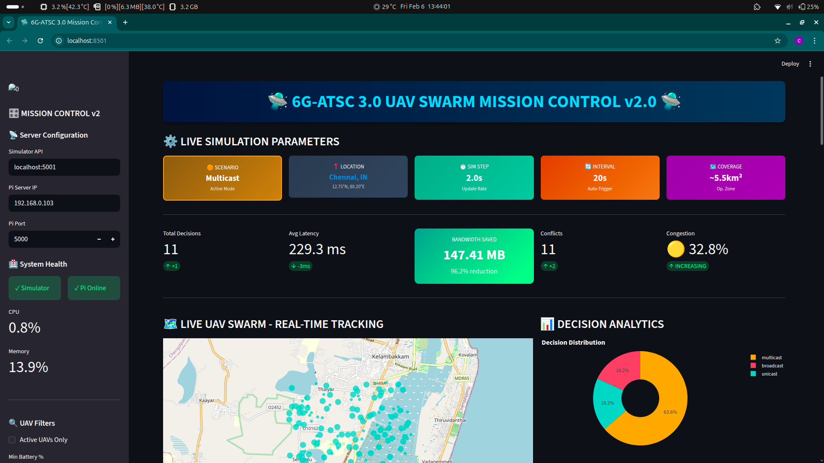

Figure 4: Dashboard of the control centre

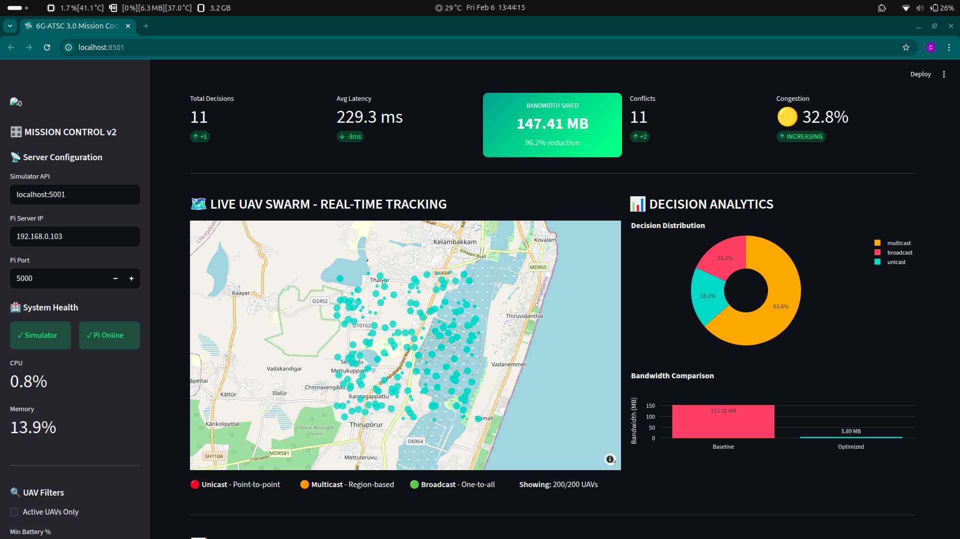
Figure 5: Geolocation of the Simulated drones
The Mission Control Dashboard, shown in Figure 4, provides a comprehensive real-time interface for monitoring the UAV swarm operations, displaying AI decision analytics, network performance metrics, and bandwidth savings visualization. The dashboard integrates multiple data streams to give operators complete situational awareness of the entire communication optimization system.

Figure 5 illustrates the geolocation distribution of simulated drones across real geographic coordinates, demonstrating the spatial deployment of 150-300 UAVs with position tracking and zone-based density visualization. The map view enables operators to identify spatial clustering patterns and areas of high UAV concentration that influence communication mode selection.

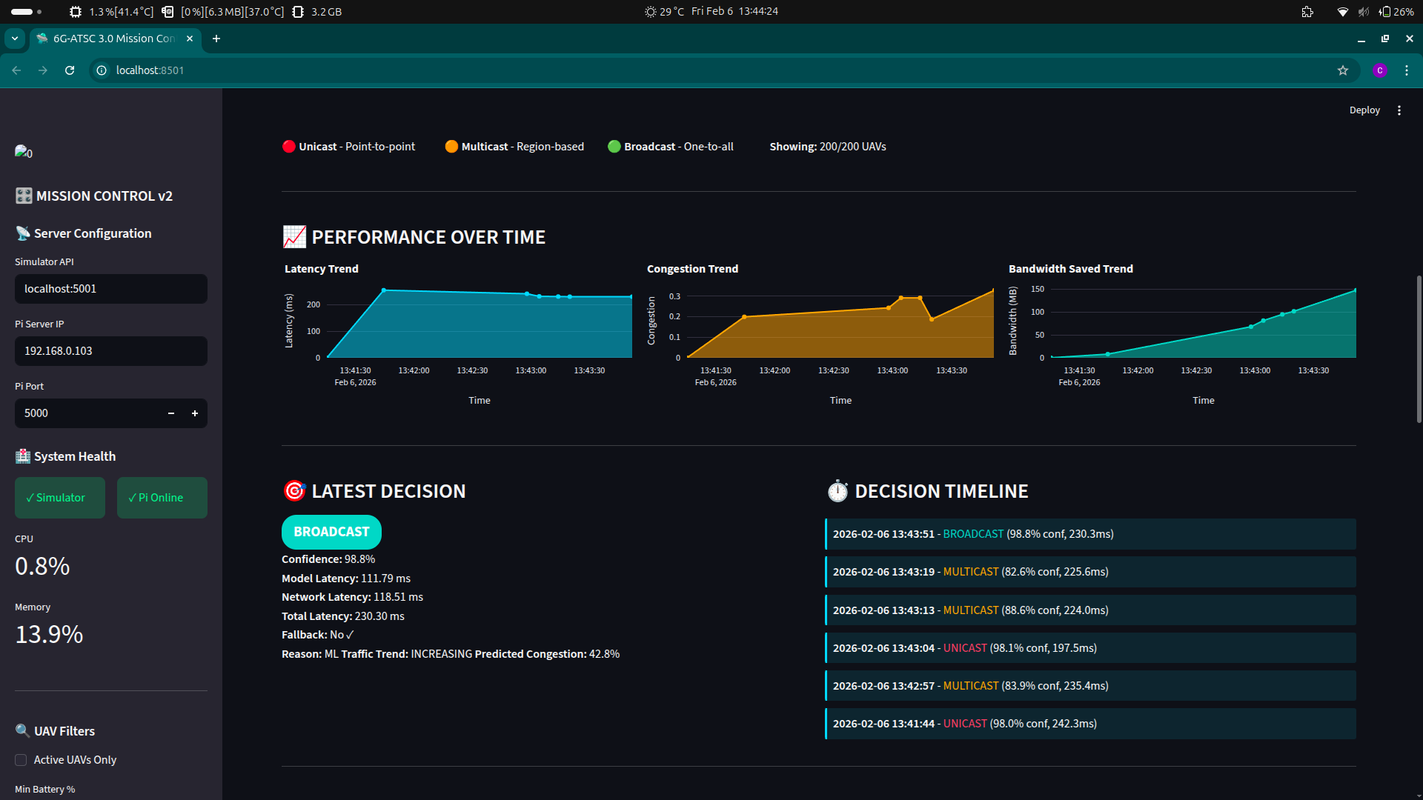

Figure 6: Performance Metrics and the Decisions made by the model

The performance metrics and AI decision-making process are presented in Figure 6, which displays the classification results for delivery mode selection including unicast, multicast, and broadcast decisions.

Each decision is accompanied by confidence scores, latency measurements, and comparative bandwidth usage analysis, demonstrating the effectiveness of the ML-based classification engine in optimizing network resource allocation.
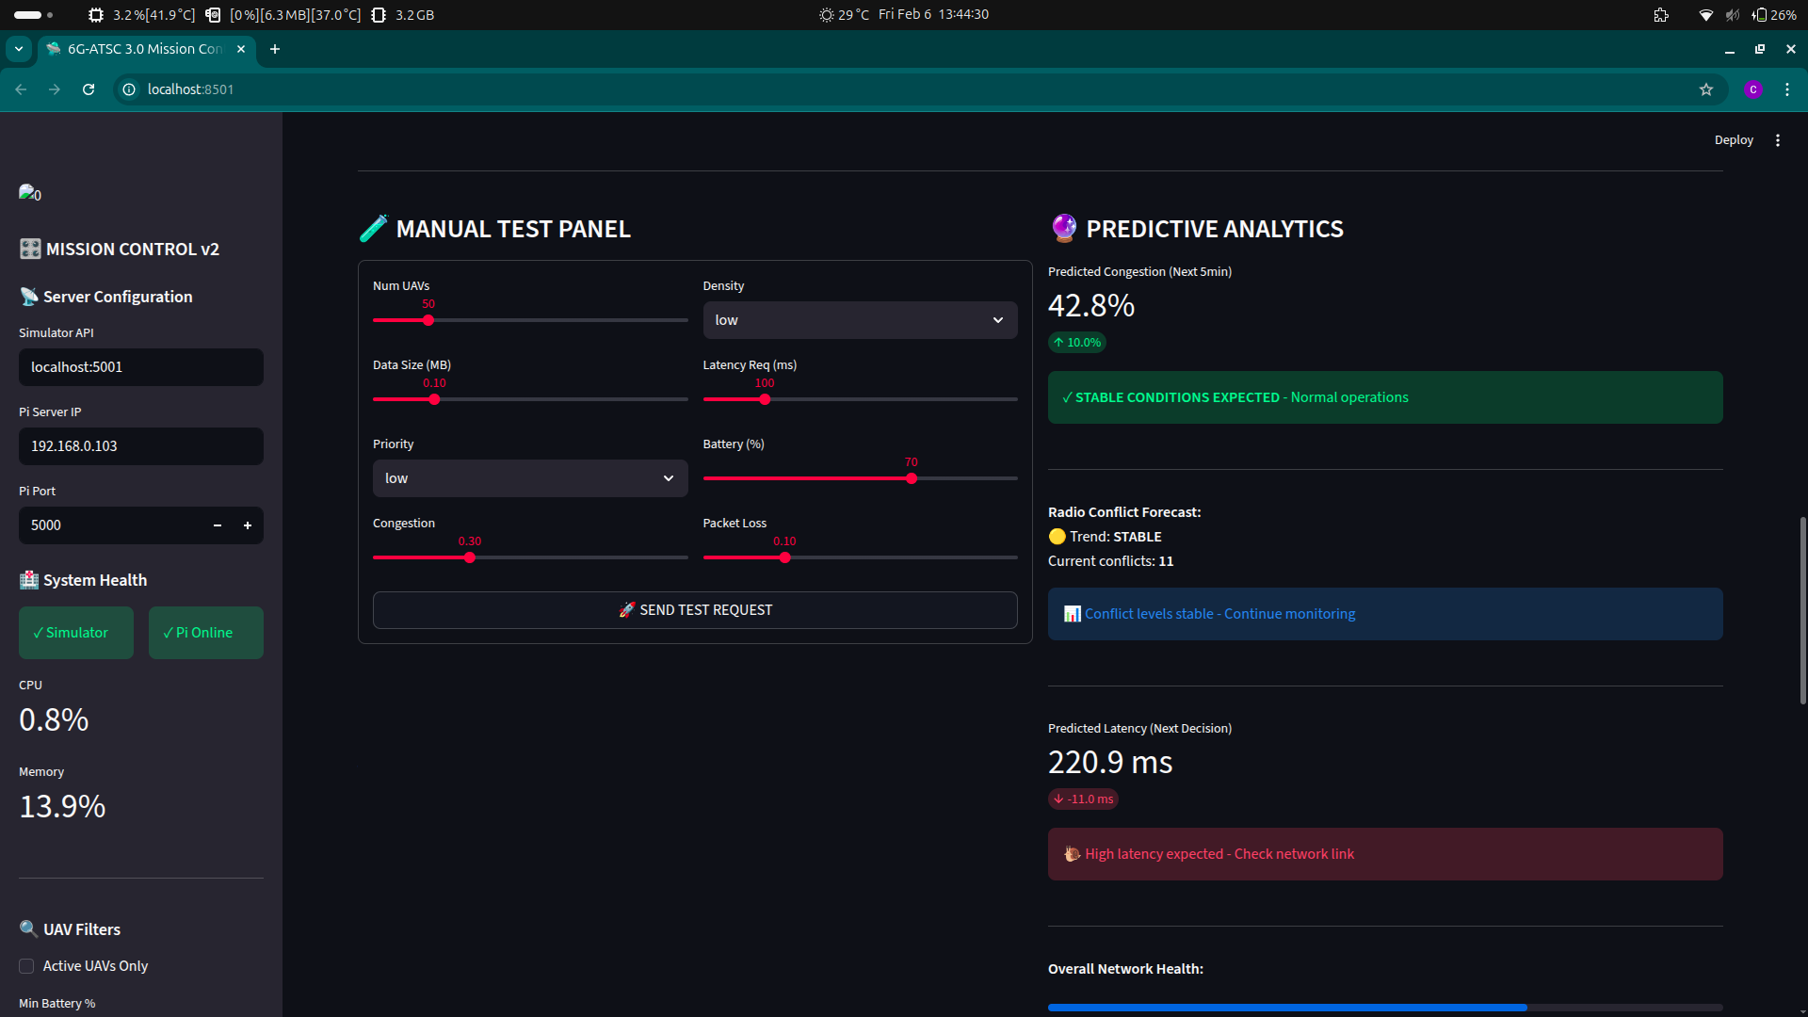

Figure 7: Manual Test panel & Predictive Analysis of other metrics

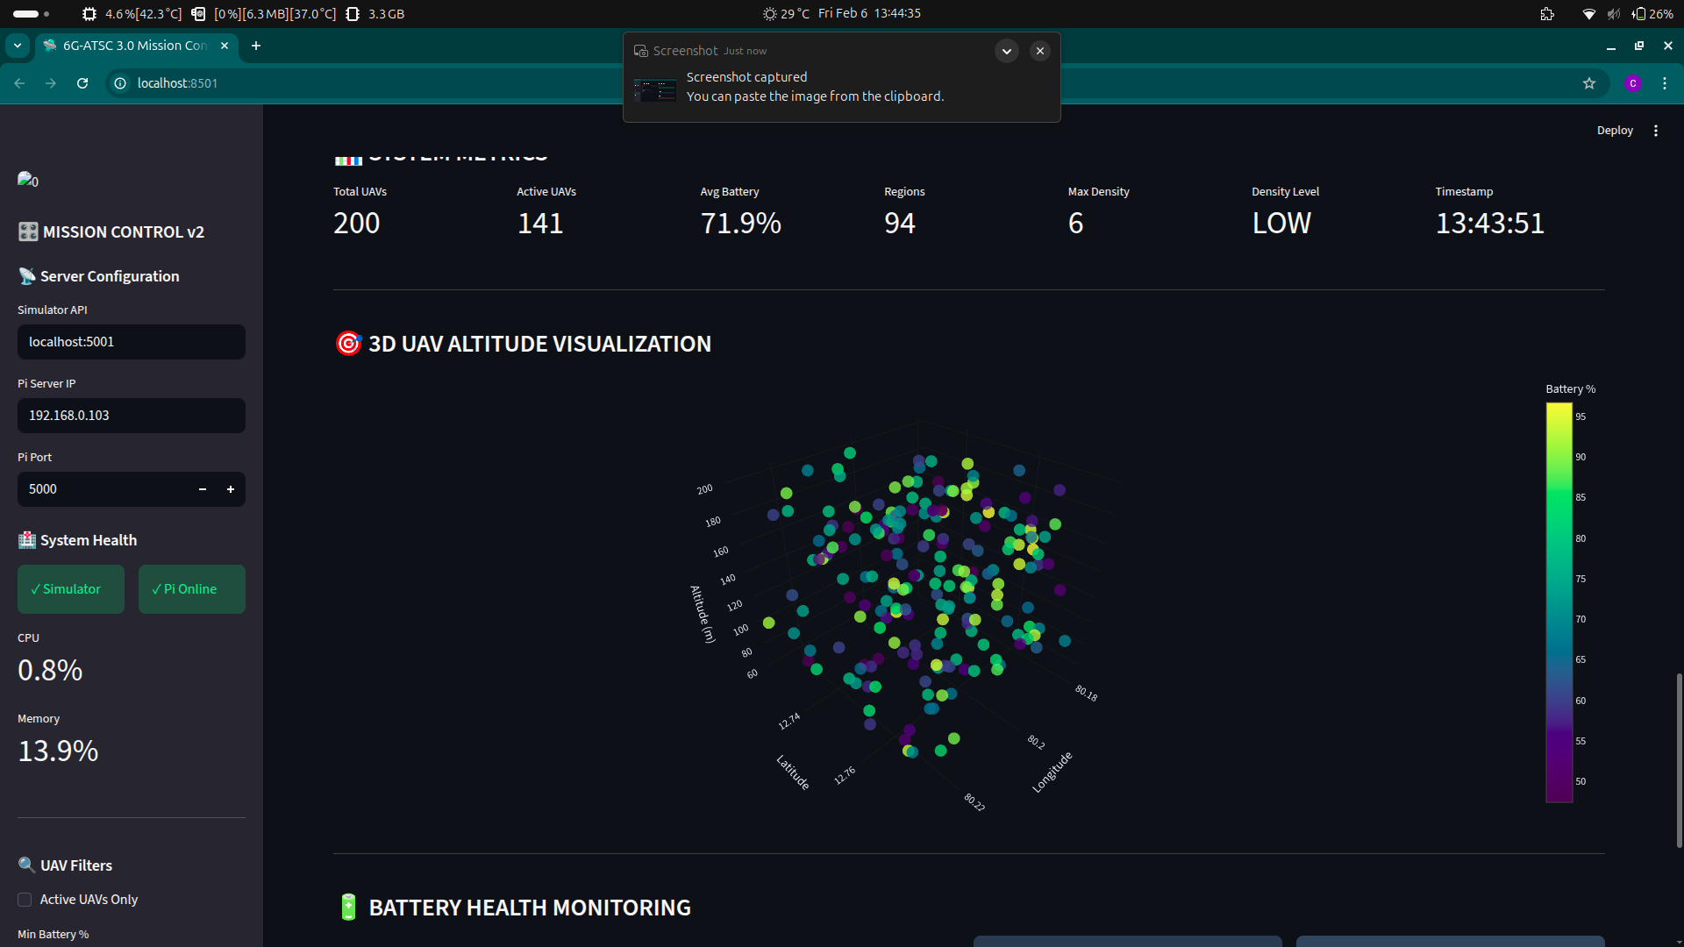

Figure 8: 3D map of the drones

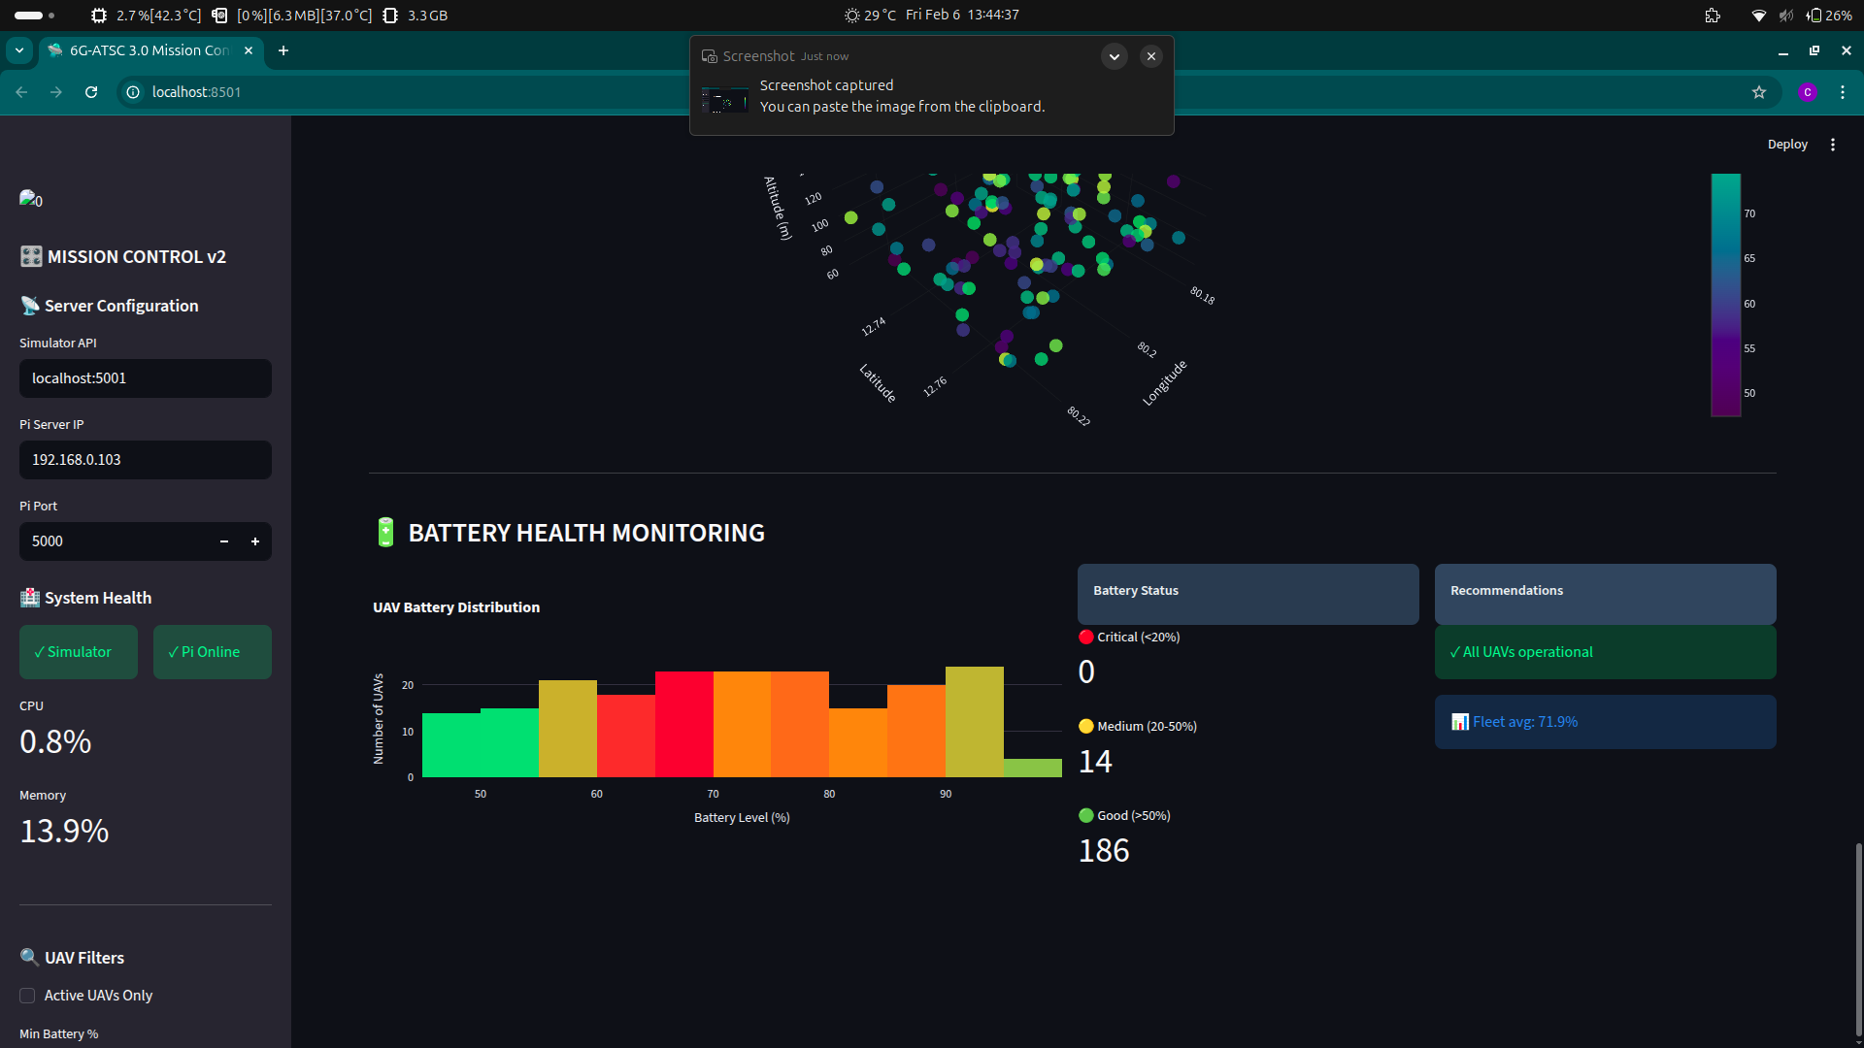

Figure 9: Battery Levels in UAV

Figure 7 showcases the manual test panel alongside predictive analysis capabilities, enabling operators to inject custom scenarios for testing while simultaneously monitoring predictive congestion trend analysis and network health forecasting. This dual-interface approach supports both controlled testing and proactive network management through early warning systems.

A three-dimensional visualization of the UAV swarm is presented in Figure 8, providing altitude-aware positioning data that enhances spatial understanding of the fleet distribution. The 3D representation allows for better analysis of vertical separation, flight patterns, and multi-layered congestion scenarios that may impact communication performance.

Battery level monitoring across the entire swarm is illustrated in Figure 9, tracking real-time power consumption patterns and remaining charge percentages for each UAV. This critical telemetry enables predictive maintenance scheduling and influences mission planning decisions, as low-battery UAVs may require priority unicast communication for safe return-to-launch commands.

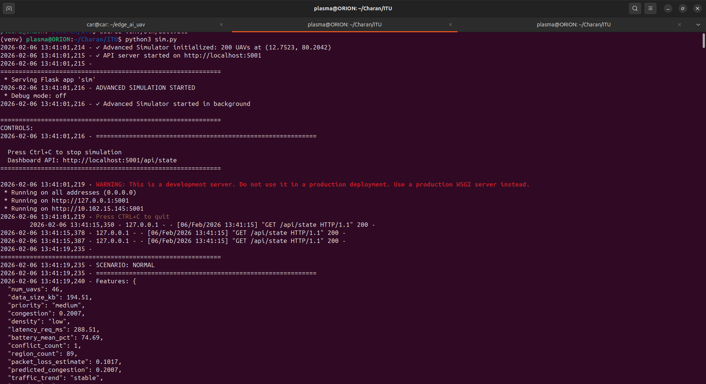

Figure 10: Simulations Started in Test Machine

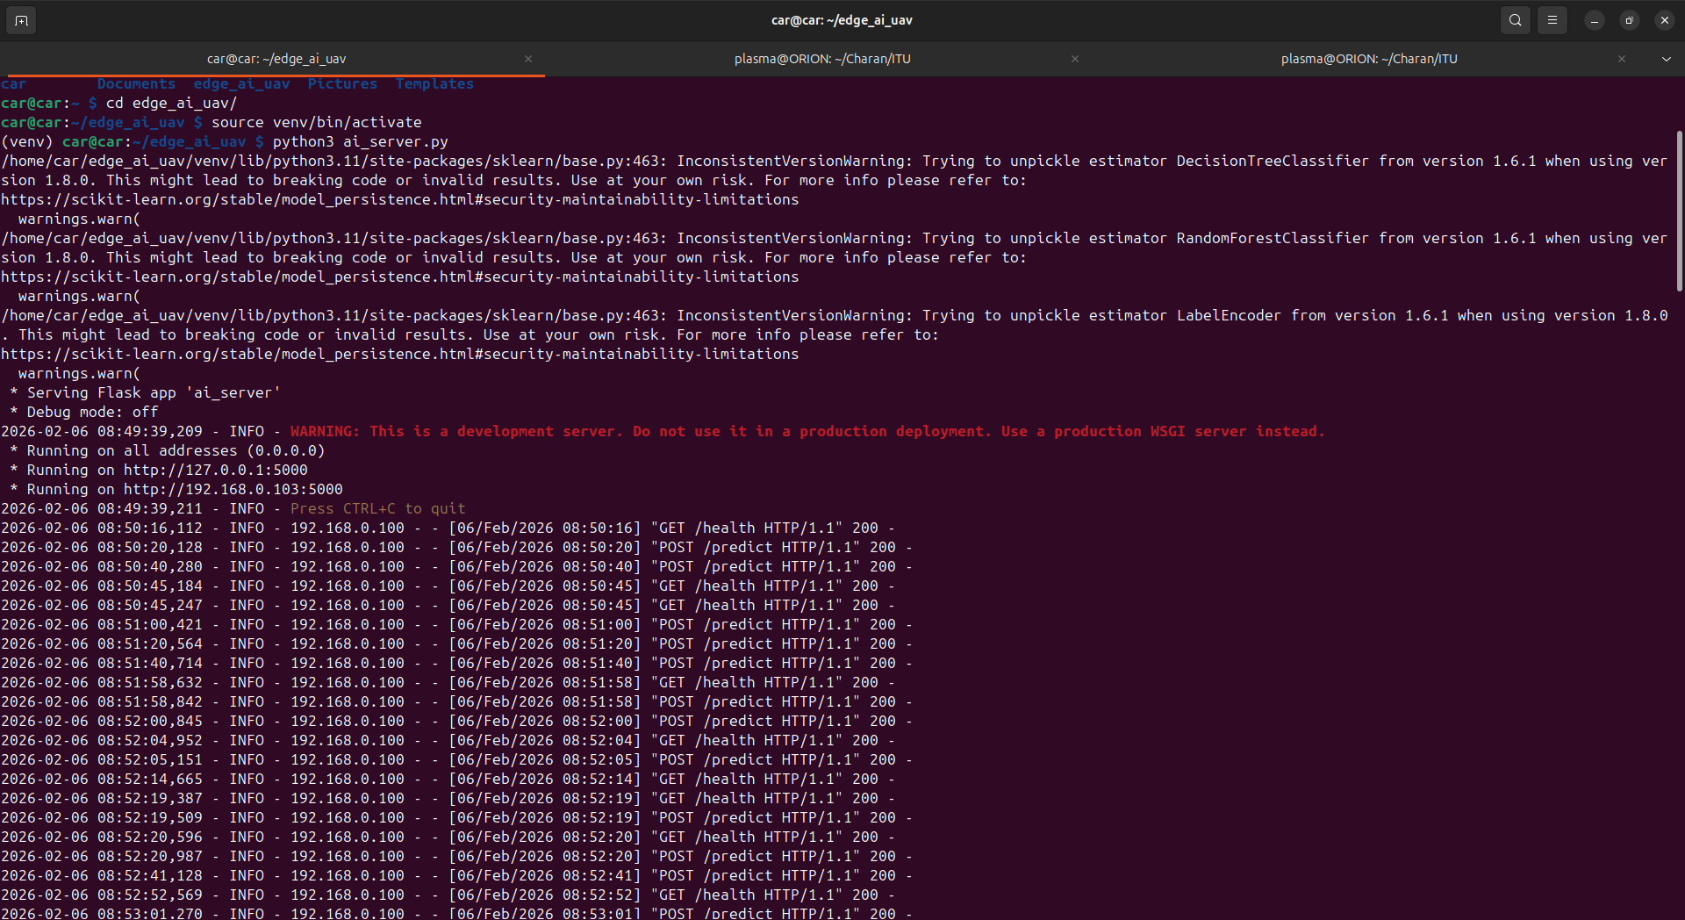
Figure11: AI server running in the Raspberry Pi
The initialization of the UAV Swarm Digital simulator is shown in Figure 10, demonstrating the test machine executing mobility models, telemetry generation, and conflict detection algorithms. The simulator creates a realistic virtual environment that feeds continuous data streams to the AI Mission Coordination Server for classification and decision-making.
Figure 11 displays the AI Mission Coordination Server actively running on Raspberry Pi hardware, performing edge-based ML inference and delivery mode classification. The interface shows real-time resource monitoring including CPU and memory usage, validating that the system operates within the specified hardware constraints while maintaining sub-100ms inference latency for optimal performance.

Scenario Comparison and Latency Analysis
Analysis of the simulation results demonstrates clear performance differences among the evaluated communication strategies, particularly in terms of latency, congestion, scalability, and bandwidth efficiency.
In the unicast-dominant scenario, control and mission updates are delivered through direct point-to-point links. While this approach ensures deterministic communication paths, the dashboard results indicate an average latency of approximately 220–230 ms when scaled to 200 UAVs. As the swarm size increases, congestion rises to nearly 30%, leading to increased backhaul usage and limited scalability. Although unicast ensures reliability for control traffic, it becomes inefficient for large-scale swarm coordination due to excessive bandwidth consumption.
The non-intelligent multicast (no-KB) scenario exhibits comparatively higher congestion and unstable latency trends. Since multicast transmission is applied without AI-based prioritization, control, telemetry, and mission data contend for the same delivery mechanism. This results in increased congestion levels (above 40%) and inconsistent latency performance, as observed in the congestion and latency trend graphs. The absence of traffic classification leads to inefficient resource utilization and reduced Quality of Service (QoS) for time-critical control messages.
The AI-driven mixed communication strategy, combining ATSC 3.0 multicast for shared mission data and 6G unicast for real-time control and telemetry, demonstrates the most balanced system performance. Although the average latency remains around 220 ms, similar to the unicast case, this is attributed to AI processing, scheduling, and coordination overhead. However, this strategy achieves significant bandwidth savings of approximately 147 MB (≈96% reduction) and maintains congestion at a manageable 32–33%, even with large swarm sizes. The decision timeline confirms dynamic switching between unicast, multicast, and broadcast modes based on real-time network conditions.
Overall, the simulation results validate the proposed design principle of separating shared mission dissemination from latency-critical control traffic. While the AI-driven mixed approach introduces moderate latency overhead, it enables scalable, congestion-aware, and bandwidth-efficient UAV swarm communication, which is not feasible with unicast-only or non-intelligent multicast architectures. This makes the proposed approach well-suited for large-scale smart city UAV swarm deployments under 6G-ATSC converged network environments.

Conclusion
Proposed UAV Swarm Communication Optimization System demonstrates a practical implementation of intelligent, converged network architecture that addresses the scalability and bandwidth challenges of large-scale drone operations. By deploying an AI Mission Coordination Server at the edge (Raspberry Pi), the system dynamically selects optimal communication modes—6G unicast for latency-critical individual commands, 5G eMBMS multicast for group targeting, and ATSC 3.0 broadcast for mass distribution—achieving up to 98% bandwidth savings without compromising quality of service for mission-critical operations.
The integration of a UAV Swarm Digital simulator with ML-based classification, mission service template knowledge base, and predictive congestion analysis creates a robust, resource-efficient solution capable of managing 150-300 UAVs in real-time. The architecture maintains sub-50ms latency for critical unicast traffic while simultaneously supporting bandwidth-intensive broadcast operations, demonstrating effective coexistence of heterogeneous network technologies.
Key innovations include edge-based AI inference with adaptive confidence thresholding, rule-based fallback for reliability, and comprehensive performance monitoring through the Mission Control Dashboard. The system's ability to scale horizontally, adapt to dynamic network conditions, and preserve QoS across concurrent communication modes positions it as a viable foundation for next-generation applications in commercial drone delivery, emergency response coordination, agricultural monitoring, and smart city infrastructure. Future enhancements could incorporate advanced 6G features, expanded multicast capabilities, and federated learning for distributed AI optimization across multiple swarm deployments.

Bibliography
- https://www.itu.int/rec/T-REC-Y.2012-201004-I/en
- https://www.atsc.org/wp-content/uploads/2025/08/A300-2025-07-ATSC-3-System-Standard.pdf
- https://www.itu.int/dms_pubrec/itu-r/rec/m/R-REC-M.2160-0-202311-I%21%21PDF-E.pdf
- https://www.itu.int/rec/T-REC-Y.1541-201112-I/en
_____________________

